Media Information Package

Living the Life You Love
The No-Nonsense Guide to Total Transformation

Paula Renaye

CONTACT
Author: Paula Renaye, 501-520-9777
Publicity: Jami Jones, 501-802-2238
Publisher: Diomo Books, 501-760-2527

Index

About the Book 1
About the Author 2
Book Excerpt 3
Author Interview Q&A 5
Reviews 8
Contact Information 10
Author Photos 11
Book Cover 13
Summary Sheet 15
Marketing 16

About the Book

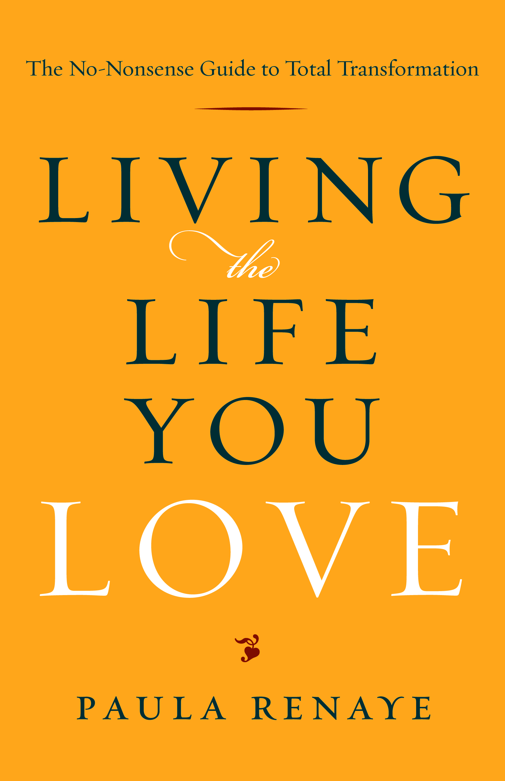
Wishing your life were different doesn't make it so. If you want to live a life that you truly love, it takes deliberate and soul-searching work to figure out what you really want, why you don't already have it and what you're honestly willing to do to get it.
In Living the Life You Love: The No-Nonsense Guide to Total Transformation, five-time award-winning author Paula Renaye shows you how to tackle what’s holding you back and make the life-transforming choices you need.
Like a best friend dispensing more than a little tough love, Renaye wraps a sturdy arm around your shoulders, forces you to look in the mirror and says, "You can do this." And with a simple, practical step-by-step process, she shows you how.
- Guided coaching sessions, personalized workbook sections and revealing self-insight techniques
- Easy-to-remember strategies to stay on track, even during those "deer in the headlights" moments
- 15 Tough-Love Reminders that motivate and hold you accountable
- How-to steps that define your dream life and build action steps to achieve it
- Instructions for creating and using vision boards and vision scripts
- 13 Sanity-Saving Strategies, including techniques for neutralizing button pushers and releasing guilt
- A simple process for turning indecision and confusion into passionate action
- Unflinching, no-holds-barred, real-life stories that cut to the heart of personal pain and turn the tables on denial, delusion and limiting beliefs

Trade Paperback • 5 ½ x 8 ½ • 288 pages • $15.95
Paperback ISBN 978-0-9674786-9-2 • eBook ISBN 978-0-9674786-8-5
Available at neighborhood and online booksellers
Diomo Books • www.diomobooks.com • 501-760-2527
About the Author

Brief Bio
Paula Renaye is a five-time award-winning author, certified professional coach and transformational speaker. She is a frequent tough-love expert on talk radio shows and in print media, and her television appearances include BookTV. To learn more about Paula Renaye and her Tough Love BFF Coach work, visit www.paularenaye.com and www.toughlovetalk.com.

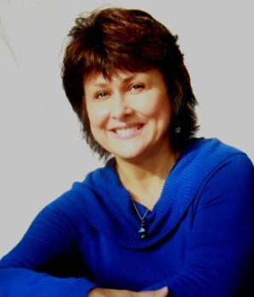
Expanded Bio
A self-confessed former eggshell walker, emotional wreck and utter failure at keeping her life from falling apart, Paula Renaye is now a full-time writer, certified professional coach, empowerment speaker and author of Living the Life You Love: The No-Nonsense Guide to Total Transformation.
Paula is a frequent tough-love expert on talk radio shows and in print media, and her television appearances include BookTV. She has won four national book awards for nonfiction self-help, and a literary award for fiction.
While working as a self-employed corporate consultant for 17 years, Paula was also developing her writing career, defining her passion and transforming herself. Writing as Paula Boyd, she and her award-winning Jolene Jackson Mystery Series have been featured in Redbook, Mountain Living, San Antonio Woman, Romantic Times, Colorado Homes and Living and many others. Paula Renaye’s recent print media features include Brain World Magazine, Brisbane Times, Sydney Morning Herald, Chicago Tribune, For You Magazine and Glo. Her blog features cut-to-the-chase articles and tips and can be found at www.toughlovetalk.com.

Contact Paula:
501-520-9777
paula@paularenaye.com
Book Excerpt
INTRODUCTION
Living the Life You Love. It’s what we all want to be doing, isn’t it? But how do we get there? How do we find what ignites our passion and makes our hearts sing, and start living that life? How do we transform the life we have into one we just can’t wait to jump out of bed and enjoy living every day?
Well, that’s what this book is all about—giving you a way to find out what your dream life really looks and feels like, why you’re not already living it and how you can. It’s first and foremost about understanding you—the real you. It’s like a true best friend who’ll wrap an arm around your shoulders and tell it like it is. A friend who’ll tell you what you need to hear, not what you want to. Then, with a solid “you can do this” pat on the back, she’ll hand you a step-by-step guide to find your own answers—and solutions. It may sting a bit from time to time, but if you’ll stay strong and keep digging, the insights you discover will speed your progress faster toward joy than you ever imagined possible.
I offer you this tough-love approach because it worked for me in a way that all the commiserating, sympathy, positive spinning and “let it go” talk never could. I wanted my life to be different and daydreamed about how I wished things were, but nothing ever changed. No matter how happy I said I was—or how loudly I complained that I wasn’t—my problems remained.
My in-your-face moment came after I had regaled my longtime best friend with yet another rendition of “poor me.” When I finally took a breath, she said to me, “Isn’t it great that for the rest of your life, no matter who you tell that story to, they’ll say, ‘You poor thing.’ And you, my friend, can be a victim forever!”
Well, that stopped me in my tracks! But I couldn’t get mad about it, because I knew it was true. So, right then and there, I changed my way of thinking—about the situation and about myself. I vowed never to see myself as a victim or tell that story ever again.
It was a huge step, but there were more to be made, and I did not make such stellar progress in other areas of my life. As you will soon see, I kept myself trapped and in pain far longer than even I can believe. Looking back, I wish someone had sat me down, eyeball to eyeball, and said something like this:
“Look, I know you’re in pain, and I hate seeing you hurt. I’ve done everything I know to try to help you. I have listened and sympathized. I have offered suggestions and recommendations. I have sent you websites, books, CDs and movies to help get you through this. Nothing is working. So, because I care about you and I care about myself, I am going to tell you that you have to make a choice. You can choose to stay in pain if you want to. It’s your life. But if you do, I will assume that your situation and your pain are what you want, and I will honor your right to keep them. I will no longer make suggestions about things you can do to feel better, nor will I suggest that you change anything about your life. I will also no longer listen to you complain about your drama, because it serves no purpose. Either do what you need to do to change what you need to change, or admit that you don’t want to and shut up about it.”
Ouch. Yes, it would really hurt to have your best friend say that sort of thing. But it could also be exactly what you need to snap you out of denial and get you moving forward. I’ll never know if it would have made a difference for me back then. I hope it will make a difference for you now.
A lot of material is packed into these pages, but you won’t find any highbrow theories that sound great when you read them and not so great when you try to put them into practice. What you’ll find are simple concepts, including real-world examples, to help you evaluate your own situation, along with practical tools to put them to use. It’s a crash course in self-discovery—a way to map where you’ve been and where you want to go, and to uncover the roadblocks keeping you from getting there.
As you read this book, take what feels good to you and start doing it. Keep working with it as you move on to the next thing that feels appropriate, and continue to add more techniques to your toolbox as you go. What speaks to you one moment may be completely different in the next, so just go with it and trust that you’ll get what you need when you need it. Go back through the book as many times as you need to. You’ll probably get something different each time, depending on what’s going on in your life and what you need most at that point.
Each chapter offers opportunities to identify the chinks in your armor; however, you don’t have to go in any particular order to benefit from this book. You can start at the end and work your way backward. Or you can just randomly open the book and see if there’s something inspiring for you in that particular section at that particular time. Make it easy. Find what works for you and use it.
A word of warning here: This is called the No-Nonsense Guide for a reason. If you don’t find something in this book that triggers some important emotional reaction, then you don’t need to be reading it! If something you read gets your hackles up or strikes you as completely ludicrous, celebrate!
What actually happens when you get that emotional hit is that something you’ve just read has triggered a limiting belief and you’ve reacted to it. That’s great! Don’t fight it. Don’t ignore that little cringe of discomfort or twinge of anger. Write down everything that comes to mind, such as “There is no way that’s right because …” or “That’s the dumbest thing I ever heard; everyone knows …” Embrace every thought, because what comes out in these precious moments can give you more insight into yourself than you ever dreamed possible. You’ll also find that the insights will start to snowball on you. You’ll like discovering why you do what you do and realizing that you can change it if you want to.
Choosing the no-nonsense, tough-love approach takes courage. It’s hard to take that first look in the mirror and not blink, but it’s absolutely essential. It’s also critical to remember that while this is about facing hard truths, it’s not about beating yourself up over where you are in this moment. We all have made plenty of mistakes, and if we had time machines we’d probably go back for some do-overs. But we can’t, and keeping our shame and guilt fresh serves no one.
So, take the loving approach for yourself, as well as for those you wish you’d done better by. Do the tough work and move on. Acknowledge the past, accept responsibility for your part in it, then forgive yourself and focus on making better choices now.
This book gives you the tools to do all that and more. They work, and it’s my hope that by using them you will find your way much better and faster than I did. I do want to make it perfectly clear that I don’t profess to have mastered everything in this book—or that I don’t have plenty more to learn. I still get angry. I still behave in reactive ways. And, I still use the techniques in this book to deal with my challenges. Today, however, it doesn’t hurt like it did at first. It’s fun … most of the time.
At the end of each chapter, you’ll find a “Transformation Insight” section where you’ll apply the concepts in the chapter to your own situation. Some are short and some are fairly long. All have a purpose, and I encourage you to be tough and make yourself really work with them. Even if you think the answers seem obvious or the questions silly, do it anyway. By taking the time and letting your thoughts—any thoughts—come to the forefront, you can find out what’s really calling the shots in your life.
Be sure you have something to record your insights on. You can use the space provided in this book or you can use a separate journal, digital document or whatever works for you. Restaurant napkins, scraps of paper and envelope backs are less desirable, but do whatever it takes. The process of writing it down is important—do it!
Okay, it’s time to get to work. The sooner you get started, the sooner you’ll be living the life you truly love!

Author Interview Q&A
- In one sentence, tell us why we should read your book.
Because it will wake you up and shake you up so that you'll actually do something about your problems, and it gives you a practical, fast-track way to do it.
- There are a zillion self-help books out there. What makes yours different?
Living the Life You Love isn't about giving you a warm, fuzzy moment so you can feel good. It has plenty of inspirational and heartwarming moments, but the twist is that they're yours—they're self-generated. They come from within, from your own self-insight process, and they won't go away after you close the book. The goal isn't to make you forget about your problems and feel good while you're reading. It's to give you the tools to push through your pain and clear it so you don't have to keep looking for feel-good fixes to help you tolerate what you know you need to change. We get right to the heart of the problems in your life—you—and take you through a step-by-step process to find solutions.
- Why did you write this book?
It’s the self-guided, personal-discovery manual I needed when I was busy banging my head against the wall, begging someone to tell me what to do and yet refusing to do it. I got plenty of helpful advice, but none of it was what I wanted to hear. I was never the problem. I just had all these other people and situations that made me upset, that's all. People commiserated and sympathized, they brainstormed and problem-solved, yet nothing ever changed—I was still miserable. What I needed was someone to sit me down and say, "Stop the nonsense! Either do something about your problem or admit you don't want to and shut up about it." Harsh? Maybe. But it took a wake-up call just like that to get my attention. We aren't doing anyone any favors by continuing to listen to the same old stories of woe from people who aren't doing anything to make things different. There's a time for sympathy and commiseration, but at some point you're just wallowing in their drama with them. This book puts a stop to that on both sides of the fence.
- Who is this book for?
This book is for anyone who is looking for a way out of limbo and turmoil in any area of life, including relationships, family, friends and work. It's also for those tired of listening to drama from others and wanting out of that. After you read this book, you will never again find yourself mired in a never-ending loop of offering solutions to people who say they want them but really don't. You won't have the patience for it and you'll know techniques to stop the cycle. It's for anyone who isn't living the life they want to be on any level, but is ready to step up to their highest potential, purpose, passion and joy.
- What do you think will surprise readers the most?
That the “tough love” approach is only "tough" at first. And, it's not me being tough on you; I'm only the messenger. It's your willingness to be tough on yourself to get where you need to go. That first look in the mirror is the hardest. After that, you'll be amazed how easy it gets and how great it feels—like a huge weight lifted from your shoulders.
- What’s the most important message readers will get from reading your book?
Well, reading is one thing—doing the work is another. If you read the book and do the work, you will transform yourself—you can’t not. You are far more powerful than you believe you are, and if you step up and take responsibility for your choices, get honest with yourself about your beliefs and do what you need to do, you’ll transform—and so will your life. Holding yourself accountable, having self-respect and owning your power of choice are the kindest things you can do for yourself.
- The several chapters offer tips, such as 33 Tips for the Dips, 13 Sanity-Saving Strategies and 15 Tough Love Reminders. Would you share a few?
One fun technique I share in my presentations is my Dodge, Distract and Detour method for dealing with negative and nosy people, or for when you want to steer clear of a powder keg topic, including talking about yourself. You dodge a question you don't want to answer, distract with a question and detour everything to the positive. The example I use is a family reunion where Aunt Edna corners you and says, "Tell me, dear, is your husband still with that little tramp he left you for?" These things do happen.
Some of the tough love reminders include: Suck It Up and Grow a Spine, Nobody Owes You Anything, Take the "Kick Me" Sign Off Your Back, Take Responsibility Not Pills and Get Your Head Straight About Health. And, of course, they come with pithy explanations and recommendations.
Tips for the Dips is a fun list of "Things to do when you don't know what to do." They range from "do nothing" to "have a pity party" to "plot a murder." Okay, that last one isn't literal; it's about writing a fictional story to work through your stuff. I'm also a mystery author and there is much to be said for creating a world where you are all-powerful and can make anyone who ever wronged you pay. Of course, once you realize you can, you may also realize you don't need to—even on paper. Some other ideas are: Learn Mind Control (yours, not theirs), Play with Rocks, Be an Alien Observer and Do an Exposure Inventory. Some are fun reminders and others are a bit off the wall—in a good way!
- So, you write mysteries too?
Yes, the Jolene Jackson Mysteries by Paula Boyd. The first, Hot Enough to Kill, was published in 1999 and the second, Dead Man Falls, won the 2001 WILLA Literary Award for Best Original Paperback. Turkey Ranch Road Rage is the third and Killer Moves is in the works in all my spare time. They're funny and a bit eccentric—okay, a lot eccentric. "Carl Hiaasen does Texasville" was how one reviewer put it. "Stephanie Plum does Dallas" might be another—or it might not!
- That's an interesting combination—self-help and mystery. Is Living the Life You Love funny too?
In places, yes, but it isn't a humorous book; it's a "get busy and get it done" fast track out of misery. It's also brutally honest, even when it doesn't reflect flatteringly on me, which is most of the time. In the mysteries, it's funny to watch Jolene struggle with her mother, childhood baggage, insecurities and fears. Not so funny when you're the one living it. But that's the point. When you come clean about all your mistakes, fears and foibles, there's nothing left for anyone to hold over your head—or for you to hold against yourself. And that's a great feeling!
- What tips in your book do you use the most personally?
All of them! Well, I do my best anyway. And when I forget and slip into negative or limited thinking, or take a dip in the pity pond, I have friends who are happy to point out that they know a really good book I could read that would help me with my little issues. They also think it's funny to quote my own words back to me (sigh).
I am a big fan of vision scripts and vision boards. A lot of people say they know about them, particularly vision boards, but not very many really understand how to create and work with them effectively. I give explicit details and examples in the book, including a lengthy sample vision script covering diverse topics that can be easily adapted and personalized. I listen to a recorded script daily of my own voice speaking positive "as if" statements, which helps keep me positive and focused. This technique for reworking beliefs on the subconscious level is very powerful for me.
- What is something you’d like to tell readers before they read the book?
It's worth it. It's worth the time, effort and yes, even the unpleasantness of looking in the mirror, to get to the other side. It may seem easier to use distractions, diversions or even drugs to tolerate what you know you need to change, but if you’ll push through the initial discomfort of seeing your own “junk” it gets so much easier after that. You've just been handed a flashlight to get through the dark forest. Use it and you won't have to bash your head against nearly as many trees.
- What do you hope will come from others reading it?
It is my hope that every person who picks up the book will experience a personal transformation and step up fully into their highest potential, purpose and passion.
Reviews
Living the Life You Love
The No-Nonsense Guide to Total Transformation
by Paula Renaye
“All the benefits of serious therapy in one book! Reading this book is like getting therapy from a top-notch therapist who has the guts to tell it like it is and the compassion to help you face your issues squarely and do something about them.”
—Amy Wood, PsyD, author, Life Your Way
“Whether you’re working with a good therapist, on your own or in a study group, Living the Life You Love is a wonderful guide to self-transformation. Paula Renaye’s style is easy and comfortable, like a friend who’s cheering you on, supportive but firm, as she guides you on the path of self-discovery. I highly recommend this book to those who are serious about transforming their lives.”
—Mimi Lupin, MA, LPC, LSSP, founder,
Making the World a Better Place Foundation
“Paula has written the quintessential manual for anyone who no longer wants to be a member of ‘the ain’t it awful club.’ This is the ticket to transformation for anyone who wants to transcend the fear and negativity that swirls around us and defy the fate of the ‘Debbie Downers’ of the world. This book will help you dare to confront your angst, claim your heartfelt personal success in your bones and go after it with passion. It will dynamite out those villainous beliefs and paradigms that have been holding you back and let you finally take flight!”
—Gail McMeekin, LICSW, bestselling author,
The 12 Secrets of Highly Successful Women and The Power of Positive Choices
“The difference in living a life you love, one you just like or one you really regret is all just a matter of choice. Paula has offered up the perfect menu for living the life that you LOVE, and this book will be one of the best investments in your happiness you will ever make. You owe it to yourself to be your best. Do it!”
—Karen Mayfield, international bestselling author, Wake up Women

“Paula Renaye challenges readers to face what’s been holding them back, then provides practical self-discovery tools to move forward. If you’re willing to do the work, this book lays out a path for rapid personal transformation.”
—Ron Chapman, MSW, speaker and author, Seeing True
“From the front cover to the back cover, I knew that this book was going to be different than every other self-help book I’ve read … and I was right! You can’t help but be affected and moved by the mirror Paula puts in front of your face. And one of the most wonderful aspects is how she shares from her own life and draws the reader into believing that change, permanent, positive change, is possible. Change takes courage, determination and direction and this book is a blueprint for making those changes in your life!”
—Deidre Hughey, speaker and author,
I Am Bound and Determined
“The author uses terrific real-world examples to make her points. For those of us wanting something better and don’t know how to get there, [this] would be an excellent first step.”
—Robin Cain, Scottsdale Examiner
“Anyone thinking about changing to achieve the life that they want will benefit from this book. Empowerment practitioners, coaches and mentors, as well as men and women—the young and mature—thinking about self-development would benefit from the knowledge and wisdom shared. It is a great resource.”
—Dr. Cheryl V. Cottle, founder,
CPC Women in Business
“The highest calling we can have as human beings is to honor our hearts. This book is much-needed tough love for courageous transformation.”
–Karen Barnett Bozeman, LCSW

Contact Information

Author
Paula Renaye
paula@paularenaye.com
501-520-9777

Publicity and Scheduling
Jami Jones
jami@diomobooks.com
501-802-2238

Publisher
Diomo Books
info@diomobooks.com
501-760-2527

Publisher
Diomo Books
PO Box 21485, Hot Springs, AR 71903
Email: info@DiomoBooks.com
(501) 760-2527
Distributor
SCB Distributors
15608 South New Century Dr., Gardena, CA 90268
E-mail: info@scbdistributors.com
Phone: (800) 729-6423
Foreign Rights
Nigel J. Yorwerth
E-mail: nigel@PublishingCoaches.com
Phone: (406) 994-0031
Paula Renaye
Paula Renaye
Return to Index
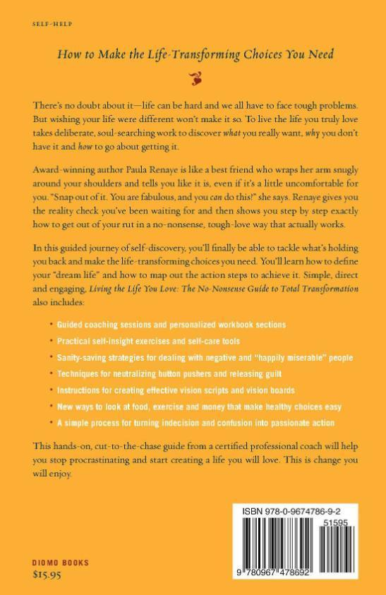
Living the Life You Love
The No-Nonsense Guide to Total Transformation
by Paula Renaye
“All the benefits of serious therapy in one book! Reading this book is like getting therapy from a top-notch therapist who has the guts to tell it like it is and the compassion to help you face your issues squarely and do something about them.” —Amy Wood, PsyD, author, Life Your Way
“Paula has written the quintessential manual for anyone who no longer wants to be a member of the ‘ain’t it awful’ club. This is the ticket to transformation for anyone who wants to transcend fear and negativity, defy the fate of the Debbie Downers and claim your heartfelt personal success in your bones and go after it with passion.” —Gail McMeekin, LICSW, bestselling author, The 12 Secrets of Highly Successful Women
“Whether working with a good therapist, on your own or in a study group, Living the Life You Love is a wonderful guide to self-transformation. Paula’s style is easy and comfortable, like a friend who’s cheering you on, supportive but firm, as she guides you on the path of self-discovery. Highly recommended.” —Mimi Lupin, MA, LPC, LSSP, founder, Making the World a Better Place Foundation

Transform Your Life from Stuck to Stunning
Wishing your life were different doesn't make it so. If you want to live a life that you truly love, it takes deliberate and soul-searching work to figure out what you really want, why you don't already have it and what you're honestly willing to do to get it.
Like a best friend dispensing more than a little tough love, Renaye wraps a sturdy arm around your shoulders, forces you to look in the mirror and says, "You can do this," and with a simple, step-by-step process shows you how.
Using guided coaching sessions with self-insight techniques and workbook exercises, you'll discover what's been holding you back and how to turn those limitations into life-transforming choices. Practical, easy-to-remember strategies help you neutralize button pushers, release guilt and stay on track, even during those "deer in the headlights" moments, while tough-love reminders motivate and hold you accountable. Whether it’s relationship, career, health or other challenges, you'll find the tools to stop tolerating what you need to change and start living the life you truly love.

Paula Renaye is a five-time award-winning author, certified professional coach and speaker. She is a frequent tough-love expert on talk radio shows and in print media, and her television appearances include BookTV. Visit her Tough Love BFF Coach blog at http://paularenaye.com.

Trade Paperback • 5 ½ x 8 ½ • 288 pages • $15.95
Paperback ISBN 978-0-9674786-9-2 • eBook ISBN 978-0-9674786-8-5
Available at neighborhood and online booksellers

Marketing

- Advertising: Psychology Today, Spirituality & Health, Publishers Weekly, Library Journal, Radio TV Interview Report and key online websites
- Drive-time radio interviews in select markets
- Reviews and feature articles in key self-help, spirituality and personal development publications, online media and newsletters
- Internet publicity campaign and blog tour
- Author events at select bookstores, specialty venues and mental health professional offices
- Seminars, workshops, classes and presentations at educational and spiritual centers
- The book will be featured at the Bejing International Bookfair August 29 through September 2, and at Frankfurt Book Fair October 10-14

